**DSP LAB Assignment-1**

Problem Description

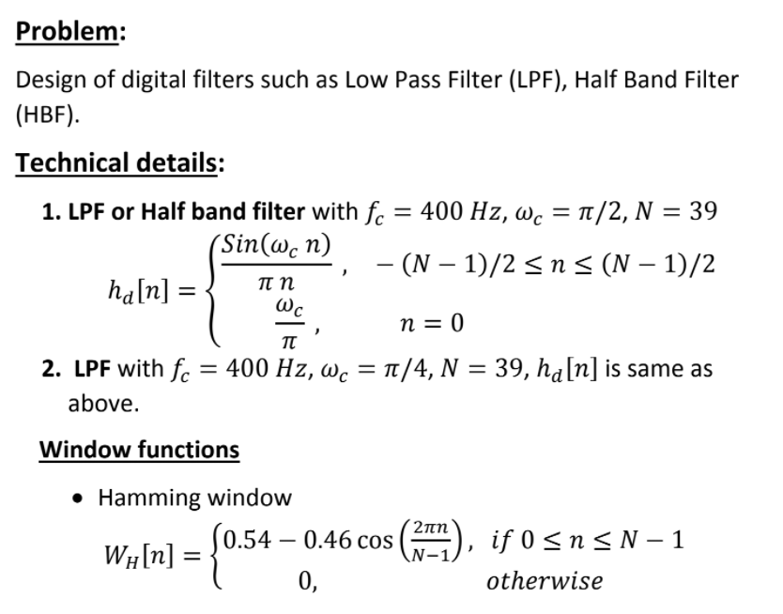

**My Understanding 🡪**

1. My assignment was to implement the filters and window function as per the problem statement.
2. The filters mentioned in the problem are digital filters that use the function as mentioned.
3. Major difference is that the cut-off frequency of (pi/2) and (pi/4) respectively.

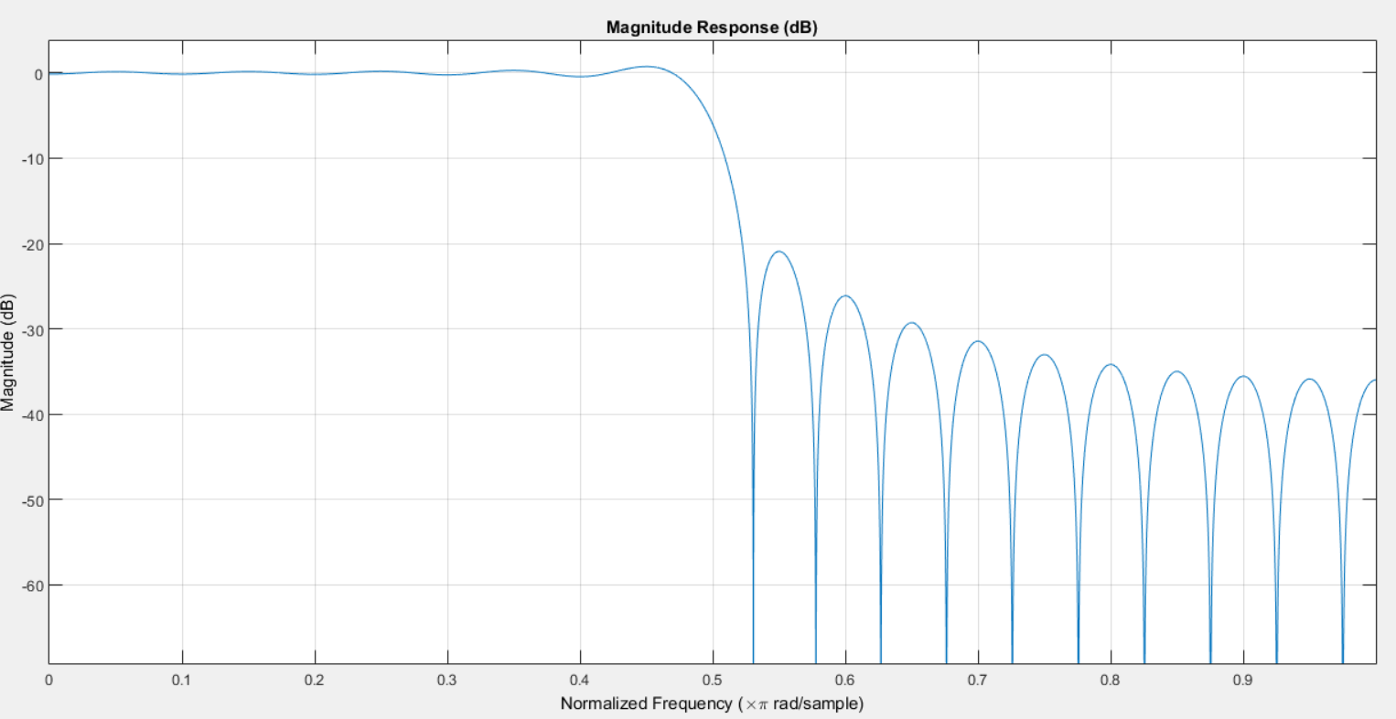

More Ripples in the stop band

Figure 1. Magnitude Response of Filter1 before use of Window Function

Cut off frequency near (pi/2)

1. Now I used the Window Function here.
2. As per the problem statement I was supposed to use Hamming window as per above shown function in the problem. The implementation was done in the MATLAB as separate function.
3. After I used the window function on my Filter below plot of magnitude was displayed in MATLAB.

Cut off frequency near (pi/2)

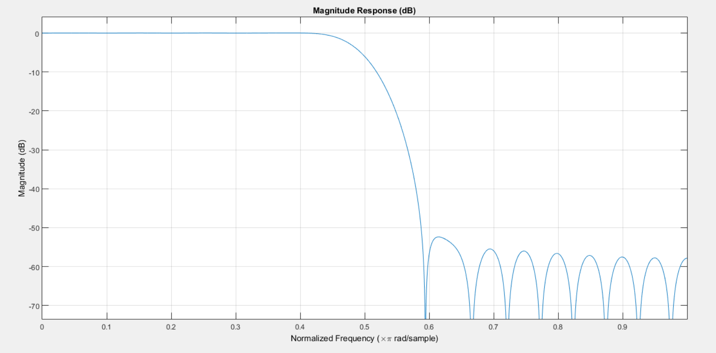

Reduce in the Ripples Magnitude in the Stop Band

Figure 2. Magnitude Response of the Filter 1 Post use of Window Function

1. Similar Observation I could see in the Filter 2 Magnitude response also.
2. Below is my observation on the impulse response of the filter 1. This means that we check time domain of the Filter1.

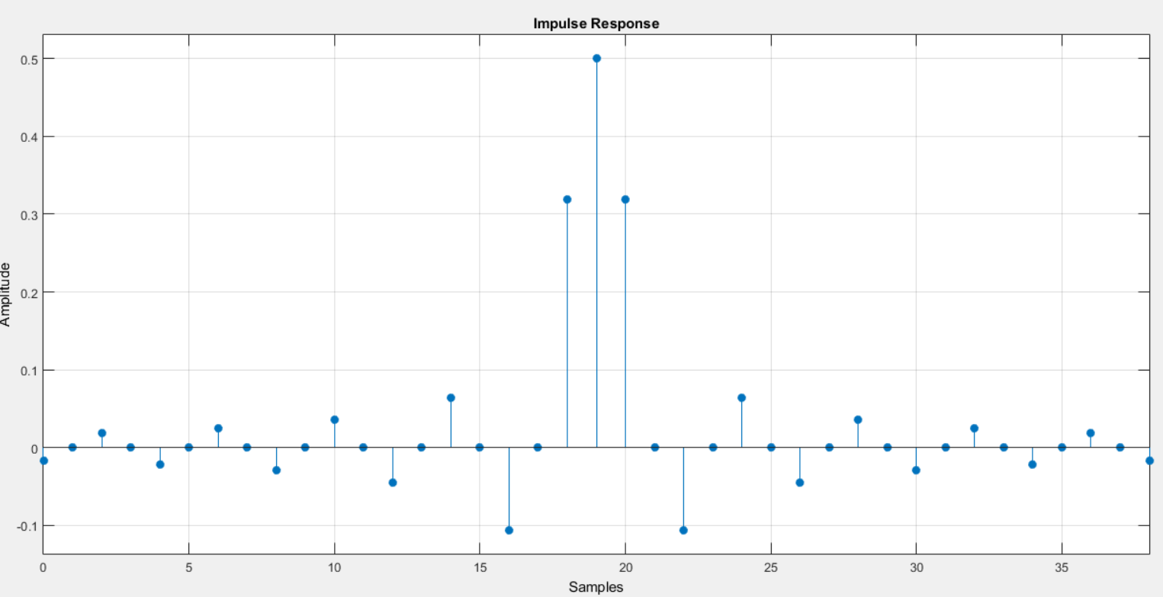

Figure 3. Impulse Response of Filter1 Before use of Window Function

We can see that Amplitude of the Samples away from Origin are supressed

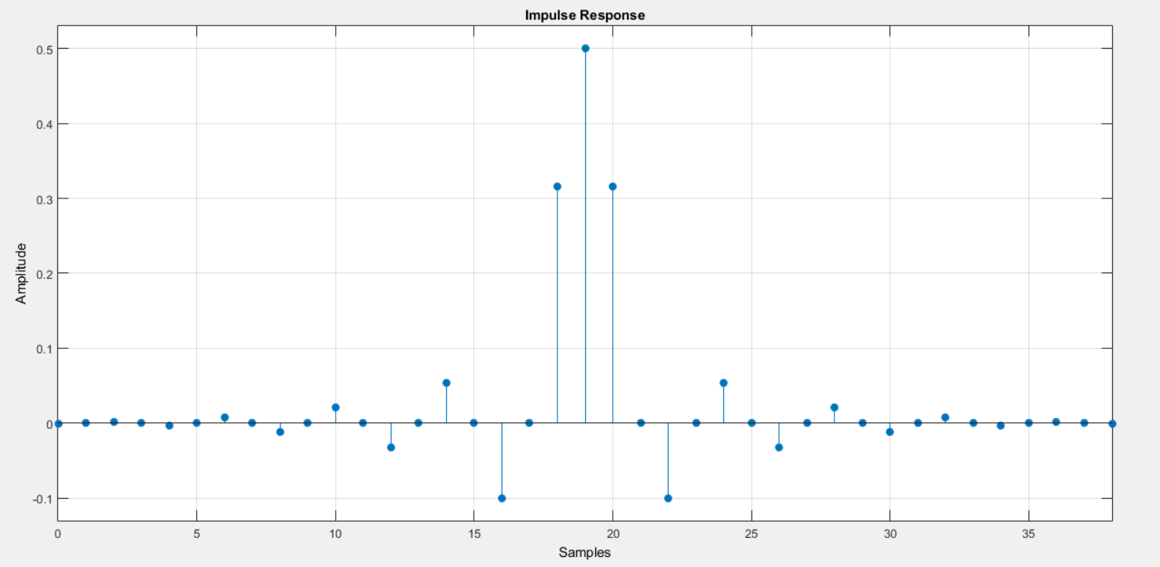

Figure 4. Impulse Response of Filter 1 after use of Window Function

1. Similar Observation is done in case of filter 2 also. See the figure attached in the pdf files.

Conclusion from the Observations above 🡪

If we want to improve the stop band characteristics of any Magnitude response of any filter, we can use Hamming Window.